PE Studies Revision Notes - Functional Anatomy:

Muscle Types:

* Cardiac-
  + - * Found only in heart
      * Involuntary
* Smooth-
  + - * Found in diaphragm and in walls of blood vessels and intestines
      * Involuntary
* Skeletal-
  + - * Muscle adjoining to skeletal bones by a tendon
      * Voluntary
      * Striated in appearance - alternating dark and light bands
      * Fusiform: fibres run parallel to each other and produces quick but less powerful force
      * Pennate: fibres run at oblique angles and produce great force but tire easily

Muscle Fibre Type:

* Slow Twitch/Type I
  + - * Red in colour
      * Contract slowly
      * Slow to fatigue
      * Suited to aerobic activity
      * Recruited during low intensity work
* Intermediate/Type IIa
  + - * White in colour
      * Can sustain activity, OR, contract with a burst and fatigue
      * Recruited during high intensity work
* Fast Twitch/Type IIb
  + - * White in colour
      * Tire quickly
      * Contract quickly and powerfully
      * Suited to anaerobic work
      * Recruited during very high intensity work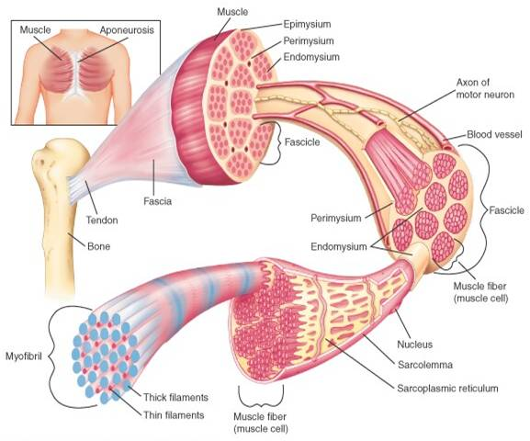

Muscle structure:

* Tendon - connective tissue adjoining muscles and bones
* Muscle belly - the bulk of the muscle
* Epimysium - thin connective tissue casing of muscle
* Fascicle- bundles of muscle fibres inside epimysium
* Perimysium - connective tissue surrounding Fascicle
* Endomysium - connective tissue surrounding each muscle fibre
* Muscle Fibre - made up of hundreds of myofibril
* Sarcolemma - thin casting of each muscle fibre
* Myofibril - comprise each muscle fibre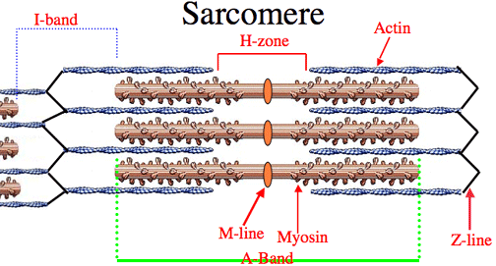
* Sarcomere - basic contractile unit of the muscle

Sarcomere:

* Myosin - thick myofilament
* Actin - thin myofilament
* Z-line - boundaries of adjoining sarcomeres
* H-Zone - space of only myosin, and can shorten or extend

Sliding Filament Theory:

* When an action potential reaches the end of the axon, it triggers the release of acetylcholine into the synaptic cleft
* This causes the muscle to be more positively charged, end plate potential
* Once threshold is reached, the muscle contracts and depolarises, causing release of calcium
* Neuromuscular stimulation causes calcium to be released into the sarcomere
* Calcium prompts reaction between Actin and Myosin Filaments by binding to actin
* This is given sufficient ATP is present
* Actin is pulled along the myosin via cross bridges; Powerstroke
* When totally contracted actin filaments overlap, H-Zone disappears
* When stimulation ceases cross-bridges release, acetylcholine is removed and muscle slides back to resting length

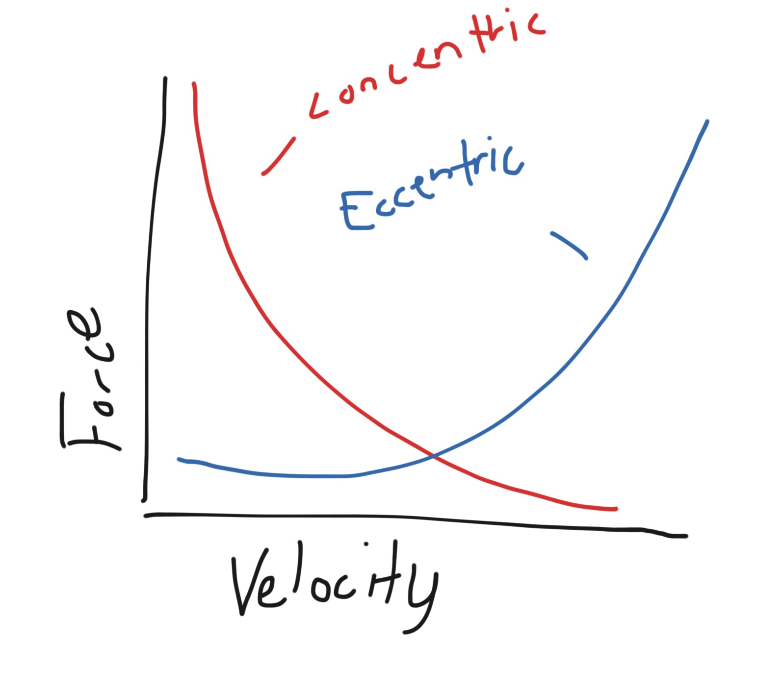

Force-Velocity:

* Isotonic force- change in muscle length against a constant load
  + - * Concentric results in shortening if muscle
      * Muscle can create increased force with a decreased velocity of concentric contraction
      * Maximum force comes at minimum velocity
      * Velocity increases at expense of force, vica versa
      * Eccentric results in extension of muscle
      * Muscle can resist increased force with increased velocity of eccentric contraction
      * Increase in velocity will result in an increased force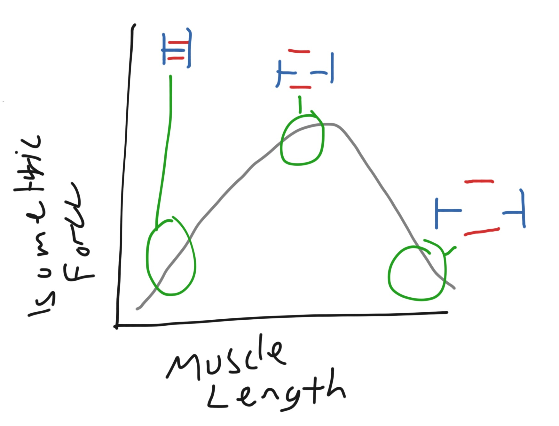
* Isometric force - muscle does not change length

Force-Length:

* Amount of force that can be produced by a muscle is dependent on its length which it is held at
* Too Short - actin and myosin are maximally overlapped so cross ridge action is limited
* Too Long- slippage of cross ridges so fewer are able to catch
* Optimal- when muscle is at 80-130% of resting length
* Longer muscles have potential to move joints through a greater range of motion
* Shorter muscles have potential to generate greater force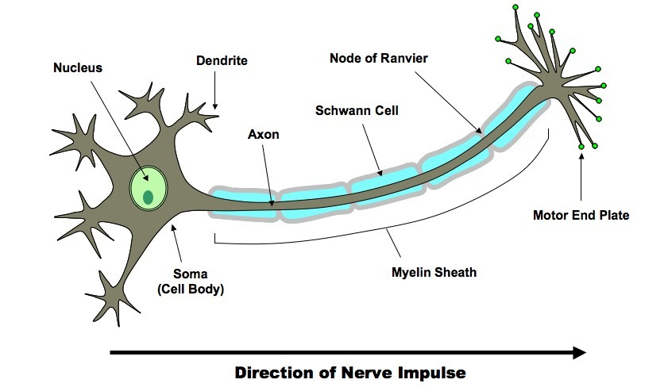
* Pre-stretching increases the potential of a muscle to produce force

Muscle Innervation:

* In order to contract, muscles must be stimulated by nerve impulses sent via motor neurons or nerves
* Message is sent from the brain, leaving as an action potential
* Motor Neuron-
  + - * + Cell Body- directs the activities of the neurone. When it receives a signal it transmits information along the length of the axon
        + Dendrites receives signals from the central nervous system  (or another neuron) and send them to the cell body
        + Axon- transmits a message to the muscle form the cell body
        + Motor End Plate- attaches to the muscle (neuromuscular junction)
* Motor Unit-
  + - * + Refers to a single motor neuron and all its associated muscle fibres
        + Can comprise of 4 up to 1000 associated muscle fibres
        + Small units create Fine movement
        + Large units used for strength
* All or None Principal:
  + - All muscle fibres within a motor unit will either contract with 100% force or none at all
    - The stimulus sent must be strong enough to breach threshold otherwise it won't fire
    - For a stronger contraction, the brain sends more stimuli, resulting in more motor units being called upon
    - All muscle fibres within the motor unit will contract at the same time (simultaneously)

Neuromuscular Response to Training:

* With strength training the first improvements are at a neuromuscular level
  + - Improved technique
    - Recruitment if more motor units
    - Increased firing rate of motor unit
    - Firing pattern of motor units are better recruited